PLASTIC DEFORMATION AND INSTABILITY IN DISCRETE GRANULAR MATERIALS WITH SPATIALLY VARYING DENSITY

Ronaldo I. Borja* and José E. Andrade†
* Department of Civil and Environmental Engineering
Stanford University
Stanford, California 94305-4020, USA
e-mail: borja@stanford.edu, web page: http://www.stanford.edu/~borja/

† Department of Civil and Environmental Engineering
Stanford University
Stanford, California 94305-4020, USA
Email: jandrade@stanford.edu
Key words: Critical State Plasticity, Material Instability, Multiscale Simulation.
Summary. We present a meso-scale nonlinear finite element modeling of plastic deformation and instability phenomena in discrete granular materials based on critical state concepts. A novel feature of the model is its ability to capture the effect of spatial density variation through the introduction of a state parameter $y$. We use several indicators to address instability, including second-order work and strong ellipticity criteria.

1 INTRODUCTION
Development of more accurate mathematical models of discrete granular material behavior requires a fundamental understanding of the effect of spatially varying density on the deformation and instability properties of such material. This paper utilizes a meso-scale finite element modeling approach to obtain an accurate and thorough capture of deformation and instability processes in discrete granular materials such as sands. We employ critical state theory and implement a three-invariant elastoplastic constitutive model for granular materials, allowing for non-associative plastic flow and formulating it in the finite deformation regime. The model contains an additional state parameter $y$ permitting “detachment” of the yield surface from the critical state line. Depending on the value of this parameter, the critical state model can reproduce plastic compaction and dilation in either loose or dense granular materials. Instability measures adopted in this study include positive definiteness of second-order work, positive definiteness of the determinant of the symmetrized acoustic tensor (strong ellipticity), and positive definiteness of the determinant of the acoustic tensor (deformation band analysis). Heterogeneity in the spatial distribution of density is modeled using nonlinear finite element analysis combined with nonlinear continuum mechanics that may be used either for: (a) deterministic analysis in which the spatial density variation prescribed in the model is measured from advanced laboratory testing procedures such as X-Ray Computed Tomography (CT) and Digital Image Processing (DIP), or (b) stochastic analysis in which the spatial density variation is prescribed from standard statistical calculations.

2 OVERVIEW OF THE MODEL
Critical state plasticity is used in almost all aspects of numerical simulations in geotechnical engineering where the soil skeleton response is represented through the effective stress. The classical modified Cam-Clay plasticity model of Roscoe and Burland [1] is by far the most widely used critical state model because of its simplicity and the fact that it requires very few material parameters. However, this model may not be robust enough for strain localization analysis since it was originally developed to capture the hardening response of soils on the “wet” side of the critical state line, and not the dilatant response on the “dry” side where it poorly replicates the softening behavior necessary to trigger instability such as strain localization. To model the strain localization of a soil more accurately, we use an alternative critical state plasticity model that contains an additional constitutive variable, namely, the state parameter $y$. Specifically, the plasticity model we propose to use is a variant of the model by Jefferies [2] and developed into a full-blown computer model by Borja and Andrade [3] and Andrade and Borja [4]. The state parameter $y$ determines whether the soil will dilate or contract when it is sheared. Inclusion of this parameter into the constitutive description enhances the ability of the model to describe the strain localization properties of soils.

3 PRELIMINARY RESULTS
Figure 1 shows two realizations from standard statistical calculations of random distribution of specific volume in a cubical specimen of sand. Both specimens have the same mean values and standard deviations of specific volume. The tight range of values of specific volume suggests that these specimens may be considered “homogeneous” for practical purposes. However, Figure 2 shows two different contours of minimum determinants of the elastoplastic acoustic tensor commonly used for predicting the onset of a deformation band. This suggests that the model is able to detect the appropriate deformation band (i.e., where it forms and at what orientation) even with minute statistical variations of spatial density.

4 CONCLUSIONS
We have proposed a meso-scale modeling approach for capturing deformation and instability phenomena in granular materials using critical state plasticity theory and nonlinear finite element analysis. This approach has been motivated in large part by recent trends in geotechnical testing utilizing X-Ray CT imaging to measure the meso-scale density variation in discrete granular materials, and DIP to quantitatively transfer the CT information as input into finite element models. The approach also can be used along with standard stochastic analysis to incorporate the effect of spatial density variation treated as a random variable.

Figure 1: Spatial variation of initial specific volume in a cubical specimen of sands (after Reference [4]).
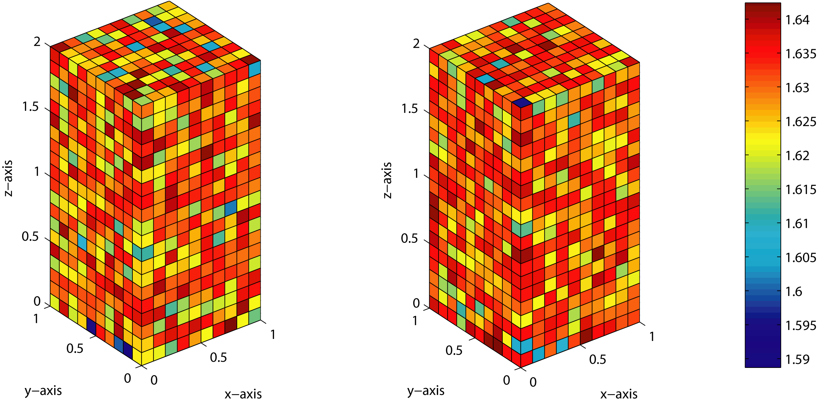
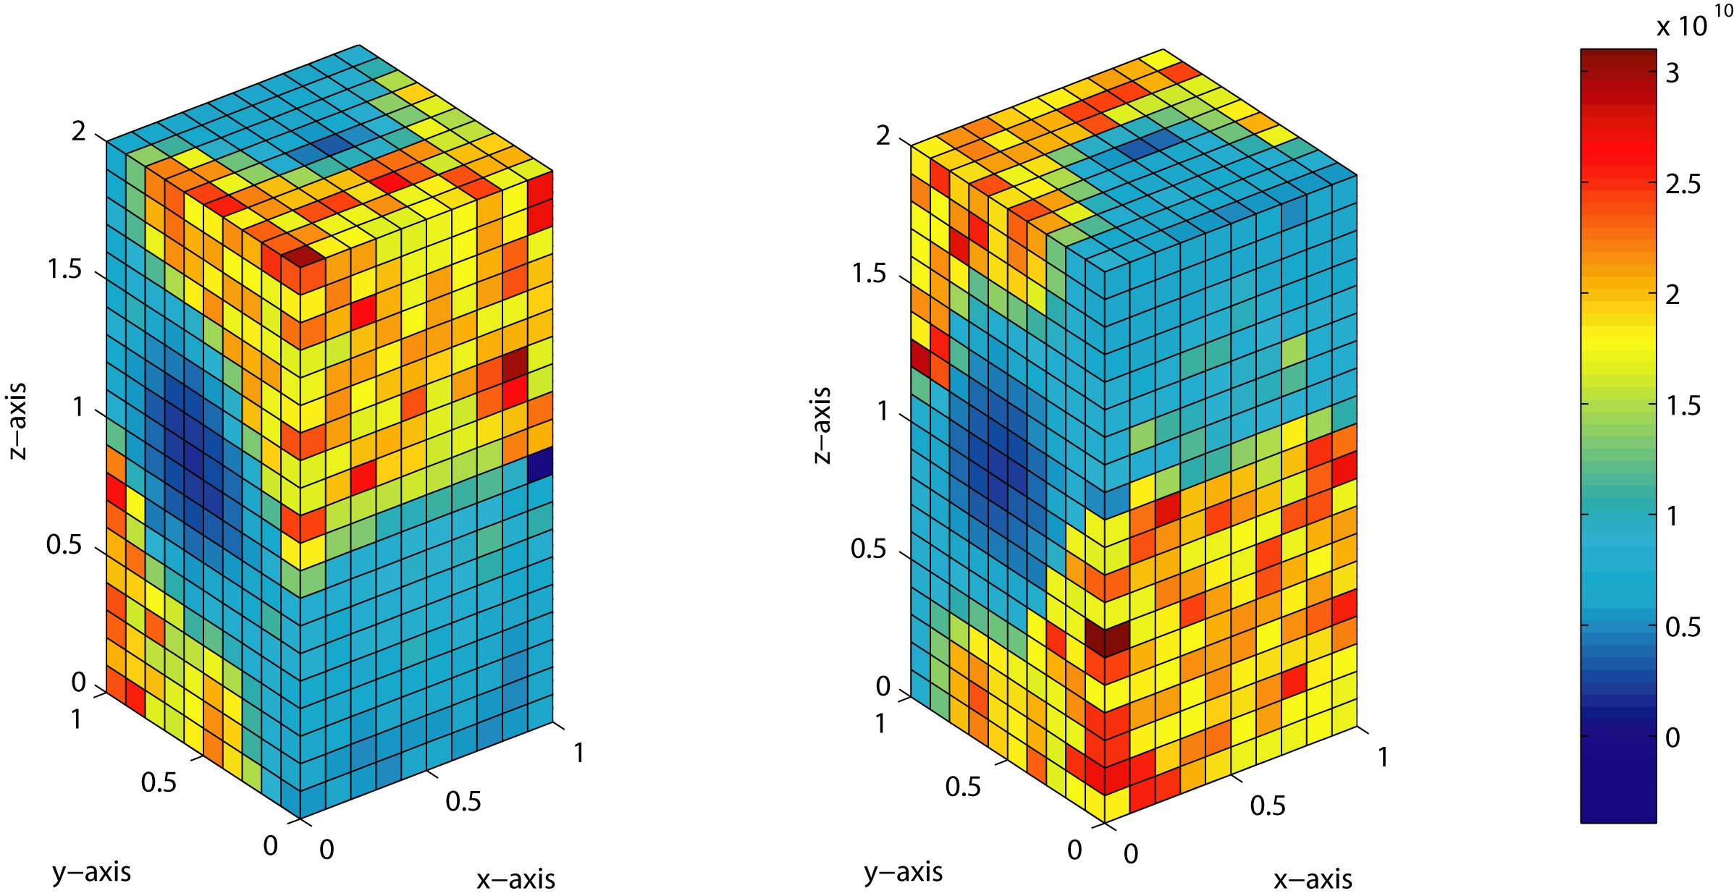

Figure 2. Spatial variation of minimum determinant of elastoplastic acoustic tensor at onset of localization (after Reference [4]).

REFERENCES
[1] K.H. Roscoe and J.B. Burland, “On the generalized stress-strain behaviour of ‘wet’ clay,” In J. Heyman and F.A. Leckie (Eds.): Engineering Plasticity, Cambridge University Press, Cambridge, 535-609, 1968.
[2] M.G. Jefferies, “Nor-Sand: a simple critical state model for sand,” Géotechnique 43, 91-103, 1993.
[3] R.I. Borja and J.E. Andrade, “Critical state plasticity, Part VI. Meso-scale finite element simulation of strain localization in discrete granular materials,” Comput. Methods Appl. Mech. Engrg., in review.
[4] J.E. Andrade and R.I. Borja, “Strain localization in sand bodies with random distribution of void ratio,” Int. J. Num. Meth. Engng., in review.

