Hotel Wilson ***

Address: Av Diagonal, 568
District: Sarrià-Sant Gervasi
Zone: Sant Gervasi
Postal code: 08021
City: BARCELONA

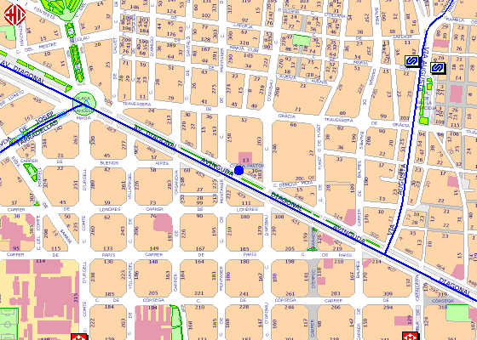

33 (25')
Take bus line 33 at Jordi Girona-Tinent Coronel Valenzuela and get down on Av Diagonal-Buenos Aires after 10 stops.

