Hotel Husa Arenas ****
Address: C Capità Arenas, 20
District: Les Corts
Zone: Pedralbes
Postal code: 08034
City: BARCELONA
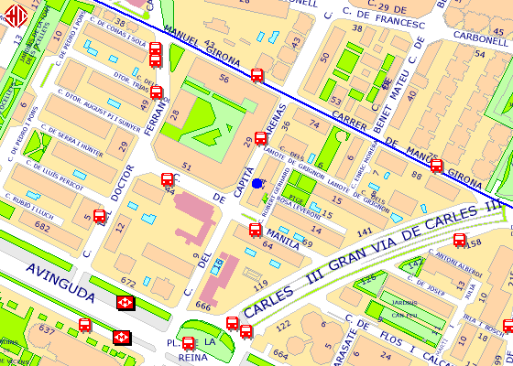

33 (18')
Take bus line 33 at Jordi Girona-Tinent Coronel Valenzuela and get down on Av Diagonal-Gandesa after 5 stops.

