Biography:
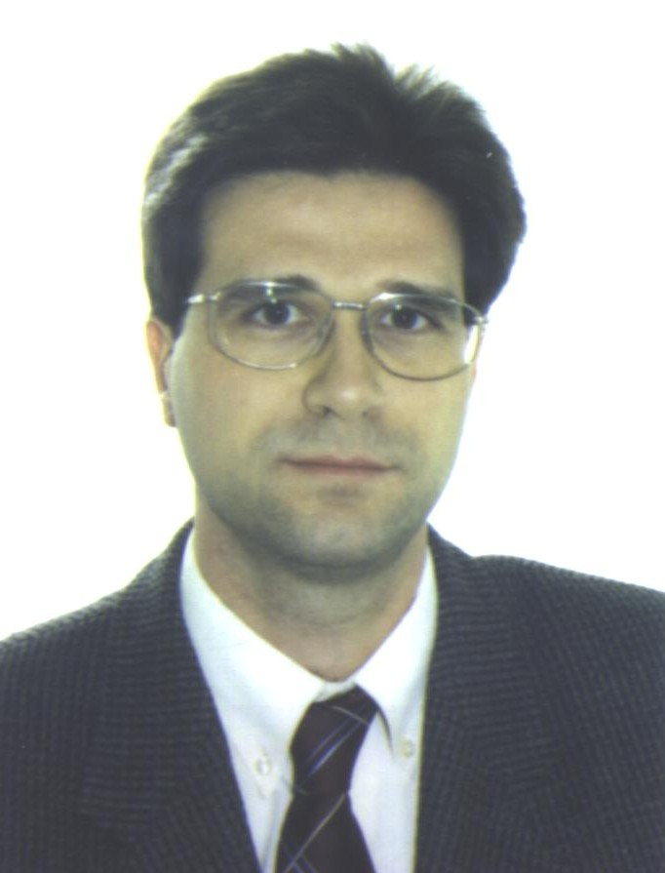 | Francesc Rocadenbosch received the Engineer and Ph.D. degrees in Telecom. Eng. in 1991 and 1996, both from the Technical University of Catalonia (UPC), Barcelona (Spain), and the Master in Business Administration (MBA) in 2001, from the Barcelona University. In 1991-92 he worked with the University of Las Palmas de Gran Canaria (ULPGC) in the field of microwave systems, and in 1993, he joined the Electromagnetics and Photonics Engineering (EEF) group, Dept. of Signal Theory and Communications (TSC) of UPC, where he is presently an Associate Professor since 1997. His research interests are in the field of LIDAR (laser radar) Remote Sensing, related system design, and signal processing.  Reviewer of well-known international journals such as Applied Optics, Optics Letters, Opt. Engineering, and IEEE Trans. on Signal Processing, he has also received the Salvà i Campillo Award of the Catalan Association of Telecommunication Engineers for the best research project (1998), jointly with the rest of the lidar team members, and the Telecommunications National Award (2003) as a member of EEF Group of the TSC Department. Joint-representative of the Remote Sensing Lab. (RSLAB) at UPC, he is currently steering the development of the UPC multi-spectral elastic-Raman lidar.

