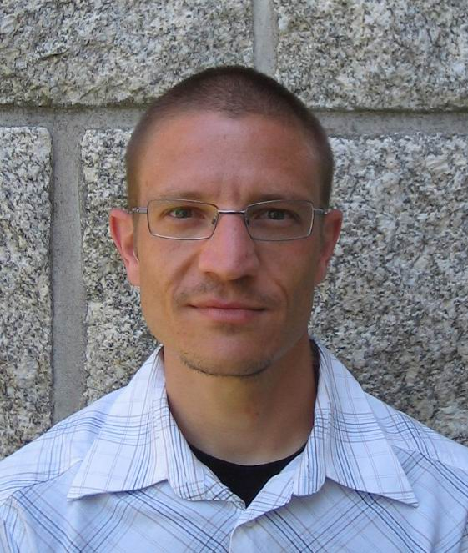
Carlos López-Martínez received the MSc. degree in electrical engineering and the Ph.D. degree from the Technical University of Catalonia (UPC), Barcelona, Spain, in 1999 and 2003, respectively.
In 1999, he joined the Signal Theory and Communications Department, UPC, where he developed his Ph.D. thesis, which focused in multidimensional speckle noise modeling and reduction. From October 2000 until March 2002, he was with the Frequency and Radar Systems Department (HR), German Aerospace Center (DLR), Oberpfaffenhofen, Germany. From June 2003 until December 2005 he has been with the Image and Remote Sensing Group – SAPHIR Team, in the Institute of Electronics and Telecommunications of Rennes (I.E.T.R – CNRS UMR 6164), Rennes, France. In 2006, he was awarded with a Ramón-y-Cajal research contract to continue his research activities at the Remote Sensing Lab. of the Technical University of Catalonia, Barcelona, Spain. His research interests include SAR and multidimensional SAR, radar polarimetry, digital and image signal processing, estimation theory and harmonic analysis.
Mr. López-Martínez received the Student Prize Paper Award at the EUSAR 2002 Conference, Cologne, Germany.

