Hotel Husa Arenas ****

Located near Diagonal Avenue, close to the city's most important business centre. Surrounded by the best stores offering an extensive variety of products and services, where you can spend a delicious day shopping or enjoy unforgettable cultural moments. Best connections to the historic centre by underground and bus.

ADDRESS: Capitán Arenas, 20
08034 Barcelona (Barcelona)
Tel. 932800303 | Fax. 932803392
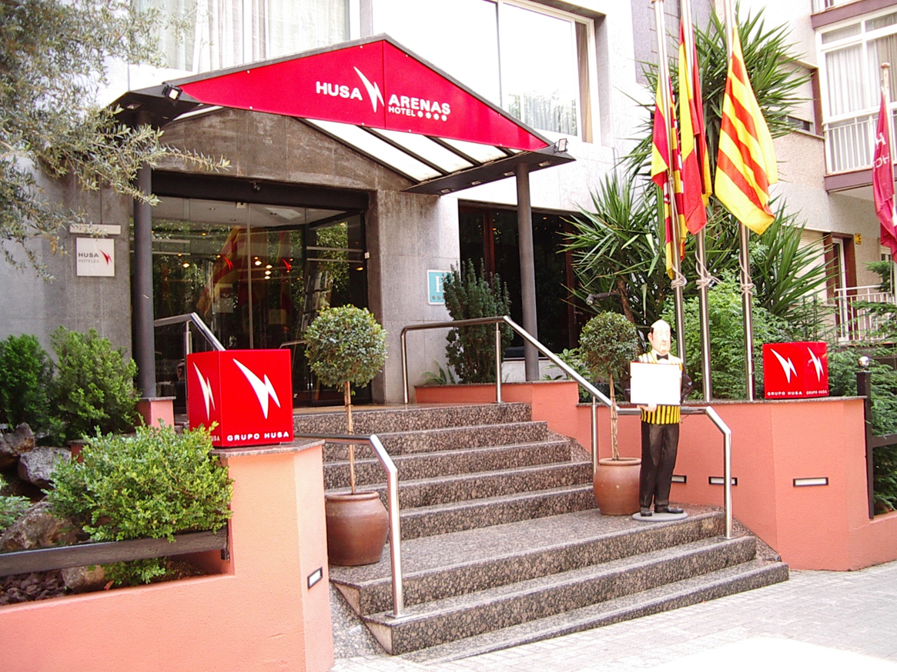

Location Map

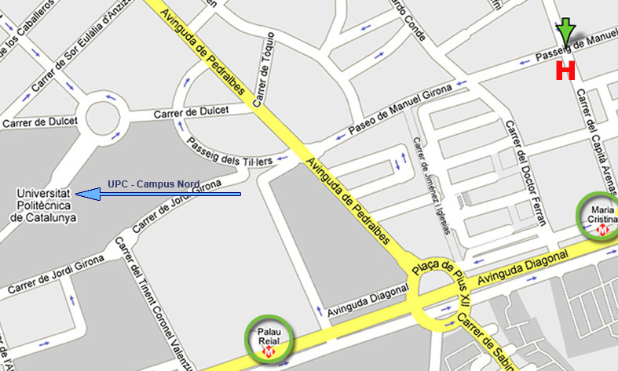

From the Hotel to the Conference Venue
By Bus : Line 33 (18')
Take the line 33 - Z. UNIVERSITARIA / VERNEDA at the station Av. Diagonal-Pl. Reina Maria Cristina (5 minutes walking from the Hotel) and after 4 stops get off at Av. de l'Exèrcit-Trias i Giró.
By Metro: Line 3 (12')

Take the line 3 - CANYELLES / ZONA UNIVERSITÀRIA of Metro at the station Maria Cristina - Av. Diagonal-Pl. Reina and after 2 stops get off at Zona Universitaria

From the Conference Venue to the Hotel
By Bus: Line 97 (13')

Take the line L97-BARCELONA (REINA Mª CRISTINA) - CASTELLDEFELS (AV.BELLAMAR) at the station Av. Diagonal (Torre Melina-Dr. Gregorio Marañon)and after 4 stops get off at Pl. Reina Mª Cristina (Gran Via Carles III). Your hotel is 5 minutes walking.

By Metro: Line 3 (12')

Take the line 3-ZONA UNIVERSITÀRIA / CANYELLES of Metro at the station Zona Universitaria and after 2 stops you must get off at Maria Cristina.

