Hotel Husa Oriente ***

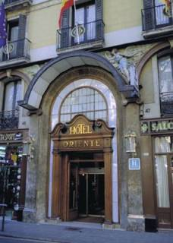

Address: C la Rambla, 45
District: Ciutat Vella
Zone: el Raval
Postal code: 08002
City: BARCELONA

Situated in the city's main shopping and commercial area, close to the famous Liceo Theatre and the Gothic Quarter.
142 comfortable and spacious rooms with complete bathroom facilities and direct-dial telephone. Restaurant. Banquet and conventions rooms. Car parking facilities 100 metres away.

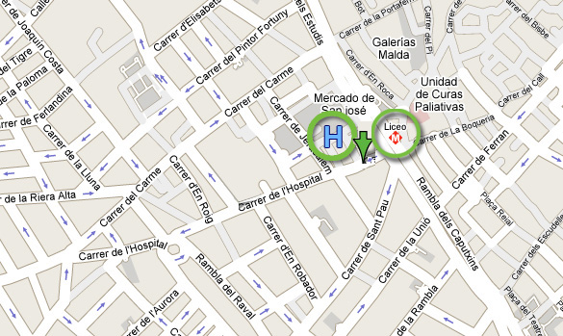
From the Hotel to the Conference Venue
By Bus : Line 59 + 67 (50')

Take the line 59 -PG. MARITIM / R. M. CRISTINA at the station La Rambla-Liceu and after 3 stops get off at Ronda Universitat-Pl Universitat. Take the line 67-PL. CATALUNYA / CORNELLA at the station Ronda Universitat-Pl Universitat and after 13 stops, get off at Av Diagonal -Metro Zona Universitaria.
By Metro: Line 3 (23')

Take the line 3-CANYELLES / ZONA UNIVERSITÀRIA at the station LICEU and after 11 stops get off at ZONA UNIVERSITÀRIA
From the Conference Venue to the Hotel
By Bus: Line 33 + 14 (50')
Take the line 33 - Z. UNIVERSITARIA / VERNEDA at the station Av de l'Exèrcit-Trias i Giró and after 10 stops you get off at Av Diagonal-Villarroel. Take the line 14 - V. OLIMPICA / BONANOVA at the station Villarroel-Buenos Aires and after 10 stops you get off at Gran Teatre del Liceu.

By Metro: Line 3 (23')

Take the line 3-ZONA UNIVERSITÀRIA / CANYELLES of Metro at the station ZONA UNIVERSITÀRIA and after 11 stops you must get off at LICEU

