Hotel Husa Pedralbes ***

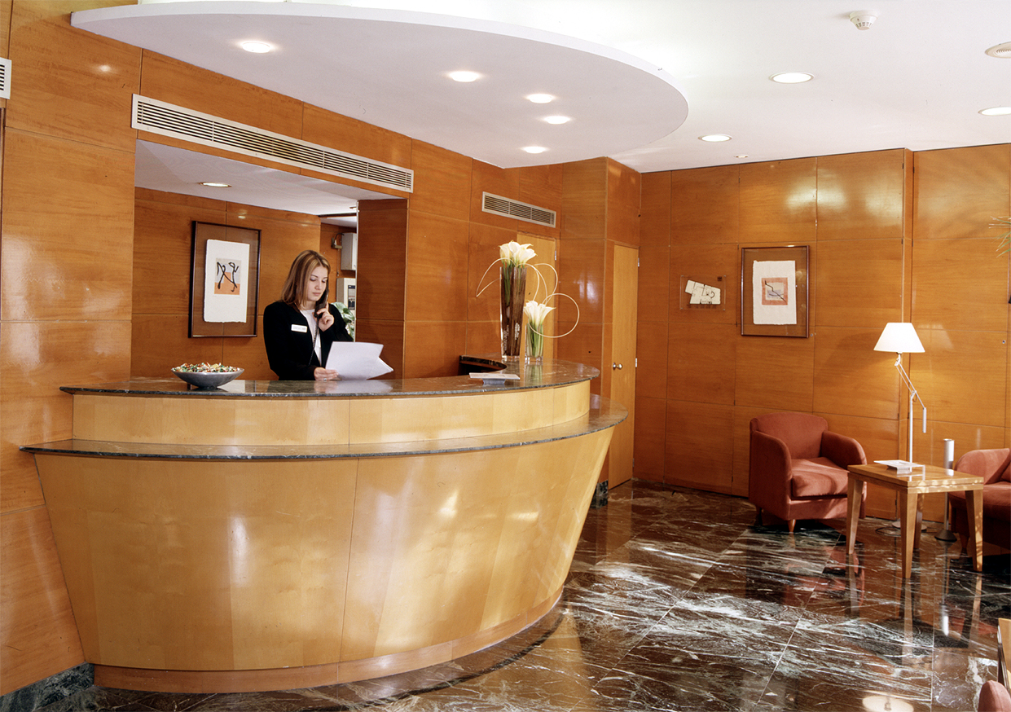
Placed in the top of the Diagonal, close to the most important core of business of the city, surrounded with the best shops. Perfectly communicated with the historical center of the city by underground and bus. 30 modern and comfortable rooms. Restaurant. Bar. Cafeteria. Own parking.
ADDRESS: Fontcuberta, 4
08034 Barcelona (Barcelona)
Tel. 93-2037112 | Fax. 93.2057065

Location Map

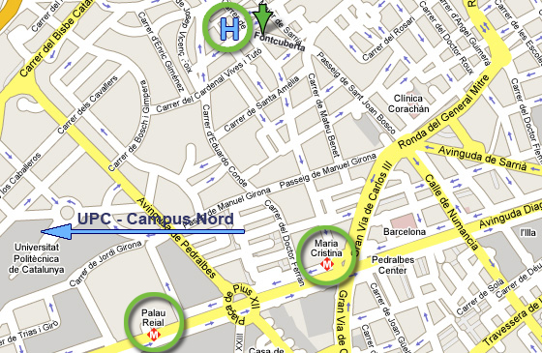

From the Hotel to the Conference Venue - By Bus: Line 74 (20’)
Take the line 74-Z. UNIVERSITARIA / FABRA I PUIG at the station Pg de Manuel Girona-Capità Arenas and after 4 stops get off at Zona Universitària.
From the Conference Venue to the Hotel - By Bus: Line 74 (20’)
Take the line 74-Z. UNIVERSITARIA / FABRA I PUIG at the station Av Diagonal-Av Doctor Marañón and after 5 stops you off at Gran Via Carles III-Numància

