Hotel Husa Bonanova Park **

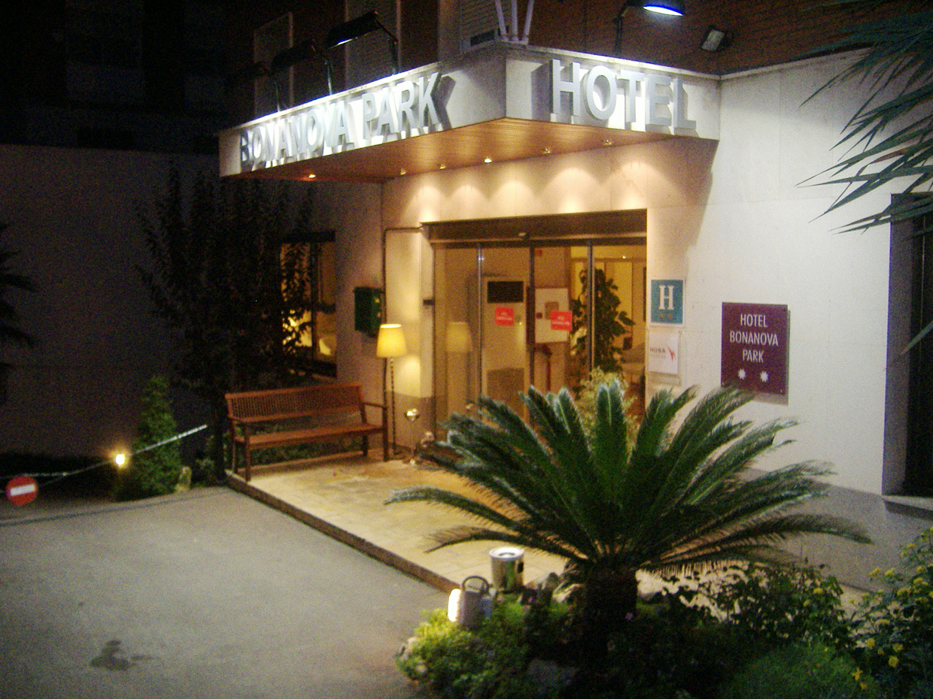

Renovated in year 2000 and located in the new business and shopping area on the Avenida Diagonal, very close to the University District, the new Congress Hall, the Barcelona Football Stadium, the Barcelona Royal Polo Club, and the Barcelona Tennis Club.Well communicated with the city centre by several bus and underground lines.
ADDRESS: Capitán Arenas, 51
08034 Barcelona (Barcelona)
Tel. 932040900 | Fax. 932045014

Location Map

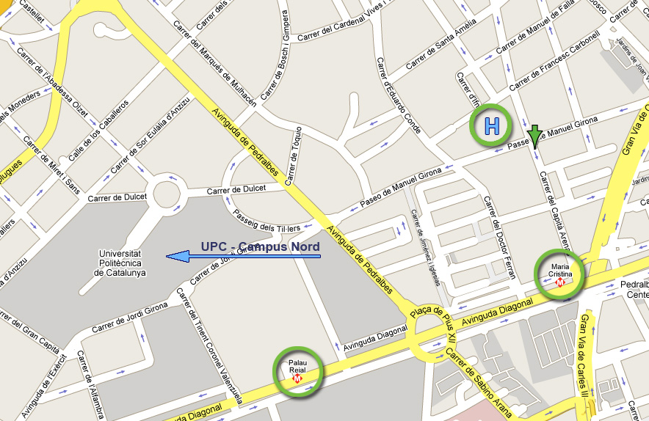

From the Hotel to the Conference Venue
By Bus: Line 74 (12')
Take the line 74-Z. UNIVERSITARIA / FABRA I PUIG at the station Pg de Manuel Girona-Capità Arenas and after 4 stops get off at Zona Universitària

By Metro: Line 3 (14’)
Take the line 3-CANYELLES / ZONA UNIVERSITÀRIA of Metro at the station MARIA CRISTINA and after 2 stops you must get off at ZONA UNIVERSITÀRIA
From the Conference Venue to the Hotel
By Bus: Line 97 (18')
Take the line L97-BARCELONA (REINA Mª CRISTINA) - CASTELLDEFELS (AV.BELLAMAR) at the station Av. Diagonal (Torre Melina - Dr. Gregorio Marañon) and after 4 stops get off at Pl. Reina Mª Cristina (Gran Via Carles III)
By Metro: Line 3 (16')
Take the line 3-ZONA UNIVERSITÀRIA / CANYELLES at the station ZONA UNIVERSITÀRIA and after 2 stops get off at MARIA CRISTINA

