HOTEL HUSA BARCELONA ****

Hotel Barcelona
Carrer de Casp, 1-13
08010 Barcelona
Spain

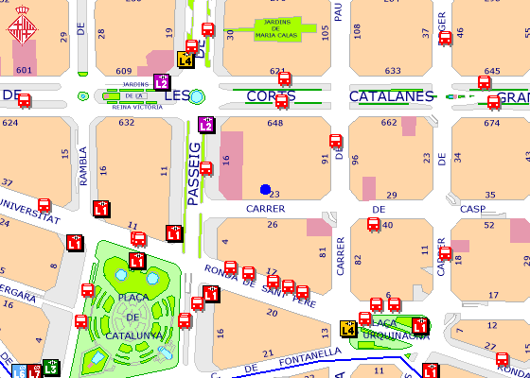

Take metro line 3 at Zona Universitaria ( Avinguda Diagonal) and get down on Catalunya after 12 stops.

