Hotel Husa Pedralbes ***
Address: Fontcoberta, 4
Zone: Sarria
Postal code: 08034
City: BARCELONA

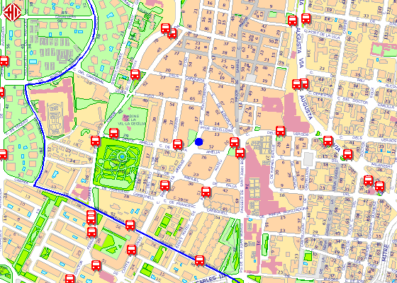
63 + 34 (32')
Take bus line 63 at Av de Pedralbes-Pg dels Til.lers and get down on Av Diagonal-Entença after 6 stops.Take bus line 34 at Av de Sarrià-Av Diagonal and get down on Santa Amèlia-Capità Arenas after 4 stops.

