HOTEL HUSA L’ILLA ****
Address: Av Diagonal, 555
District: Les Corts
Zone: Les Corts
Postal code: 08029
City: BARCELONA

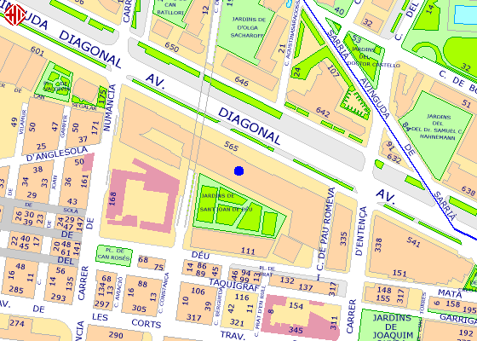

L3 (23')
Take metro line 3 at ZONA UNIVERSITARIA ( Avinguda Diagonal) and get down on MARIA CRISTINA after 2 stops.

